Kiev report:

Final Draft Chapter:
12. Environment and human health

12. The environment and human health
There is growing concern about the links between the environment and health. Worldwide, and probably also in Europe, one quarter to one third of the burden of disease is attributable to environmental factors. Vulnerability, however, varies markedly between different groups and areas.

There is reasonable understanding of cause-and- effect relationships between water and air pollution and human health. The health consequences of climate change and chemicals in the environment result from complex interactions between causing environmental factors and human beings which are far less understood. For some chemicals, such as endocrine disrupting substances, the effects on humans are particularly difficult to unravel.

While there have been some improvements in European levels of water and air pollution during recent decades, a number of health-related problems persist, particularly in some eastern European countries and the Newly Independent States. Transport continues to be a significant contributor to health effects through pollution, and to mortality and morbidity through accidents.

Although there is little direct evidence of human health effects, chemicals in the environment and the disposal of wastes continue to be of concern.

12.1 Introduction
The past decade has seen various achievements which give grounds for optimism about improvements in Europe’s environment and health in the twenty-first century. However, it also shows that the region still faces many urgent and serious challenges (WHO, 1999).

People feel very concerned about the links between their environment and their health, more so now than in the early 1990s when environmental issues were much higher on their and the media’s agenda (EEA, 1999). This concern is clearly reflected in the London Declaration in which European Ministers of Environment and Health committed themselves to taking action on a number of issues, based on the precautionary principle, (WHO, 1999).

Overall, it is estimated that 25 – 33 % of the global burden of disease is attributable to environmental factors (Smith et al., 1999). There is every reason to believe that the European figure is similar. However, although everyone is vulnerable to environmental impacts, the ability of people and societies to adapt and cope is very varied. Vulnerability is not equally spread, and some groups (e.g. poor people, children, women, old people) living in vulnerable areas (e.g. floodplains, river banks, small islands, coastal areas and high latitudes) are at greatest risk.

Cause-and-effect relationships are quite well established for some issues, e.g. water and air. In these cases the relationships can be described in a succinct way and a responsive approach can be taken. For others, e.g. climate change and wastes, the impacts on health are often delayed, or are the product of many, perhaps small, environmental factors acting together. The description of human health effects is often less precise, and a precautionary approach may be more appropriate. Also, monitoring of the crucial cause-and-effect relationship is quite weak, although environmental health indicators are now at an advanced stage of development and testing (see box 1).

Box 1

Environmental Health Indicators

Background: The 3rd Ministerial Conference on Environment and Health (London, 1999) acknowledged the need for further development of information and assessment systems as a basis for implementing and monitoring policies and also for communication with the public.

Data systems on environment and health are spread among different agencies and the links between environmental impacts and health effects are not sufficiently considered. It is also difficult to compare the environmental health situation across Europe since the methods of data collection, reporting, analysis and communication are not harmonised.

Objective: Recognising these problems, WHO Europe, supported by a large group of Member States, and in collaboration with the EEA, is developing and testing a pan-European system of Environmental Health Indicators covering all main environmental issues of health relevance.

The process: A set of ‘core’ indicators has been selected for pilot implementation on the basis of a feasibility study in fourteen Member States. The set includes indicators that are feasible, relevant for policy and that enable comparative assessments across Europe. Selected countries of the WHO European region have volunteered to pilot test the proposed indicator system.

Outcomes: When established, the system should:
- enable tracking of progress in environmental health across Europe;
- provide countries with appropriate environmental health information to make comparisons and support their national policies;
- contribute to the broader objective of reporting on sustainable development.

A proposal for a comprehensive system of environmental health indicators linked with assessment and reporting mechanisms will be prepared for endorsement by Ministers of Environment and Health at the 4th Ministerial Conference on Environment and Health in Budapest, 2004, for implementation in the WHO European Region.

Source: http://www.euro.who.int/EHindicators

Box 2

Children – A vulnerable group to Environmental Health

Most European children today benefit from better food, cleaner water, more preventive health measures, such as vaccination, and a higher standard of housing and living than ever before. Globally, however, about 1 in 10 children will not live to see their fifth birthday, although this global average conceals wide variations in different parts of the world. This is chiefly due to infectious diseases, which still kill many children in the less developed world. There are also parts of Europe, such as the Newly Independent States (NIS), where, following social and economic breakdown, the classic infectious diseases, such as diphtheria, malaria, TB, cholera, and typhoid, are re-emerging. The life expectancy of people in NIS has fallen dramatically within the last decade to an average of less than 50 years in several of the more polluted and impoverished zones, such as in Uzbekhistan, Kazakhstan and Tajikhistan. Infant mortality rates in Europe vary enormously, reflecting the large differences in social, economic, and environmental conditions, as well as the health care systems across the European region.
While most children in Western Europe are no longer dying of infectious diseases, they are at increased risk from some cancers and birth defects, as well as asthma, allergies, brain damage and behavioural disorders. This has been called the ‘new paediatric morbidity’. The causes of these diseases are not as obvious as the causes of infections, but as they have grown to prominence fairly recently, changes in the environment and other factors of modern life are likely to be playing a significant role.
Children today are routinely exposed to a number of ‘hidden hazards’ from micro-pollutants in air, water, food, on soils and surfaces, and in consumer products. These include newly created synthetic chemicals, which did not exist fifty years ago. For 75% of the 70-100,000 chemicals on the European market, there is insufficient toxicity information available for even the most basic risk assessments recommended by the OECD. Children are not “little adults” but are particularly vulnerable to pollutants because of their immature biological development; behaviour; metabolism; greater exposure to pollutants, relative to body weight; and longer life at risk than adults. “It’s the timing of the dose that can make the poison”.
Children are therefore potentially more vulnerable to environmental hazards than adults, and require special protection. However, this is not generally provided for since most safety standards for chemicals are based on adult data, although improvements to standards are developing continuously. Some pesticide residues in food and water, because they can accumulate in the particular diets of children, are of concern, especially for possible impacts on the brain and on behaviour. Environmental causes of autism, attention deficit/hyperactivity disorder (ADHD), and lowered IQ are being investigated and seem to be involved in some of the increases in these disorders.
Some other chemicals that can damage the brain and affect behaviour are lead, mercury, PCBs and dioxins which can be absorbed via food, water, air, surfaces and consumer products. Some chemicals (PCBs, dioxins) accumulate in body fat and are passed on to the foetus and infant. Although more dose is passed on through breast milk, the lower, pre-natal dose via the mother appears to be more hazardous because of the greater vulnerability of the foetal brain. Hormones in meat may cause brain damage and cancer.
Other environmental health impacts on children seem to include: reproductive disorders (cancers and defects of the testes, breast cancer, falling sperm counts); asthma; other respiratory diseases and allergies; some other cancers, such as leukaemias and nervous system tumours; and injuries, for which there is a steep difference between W. and C&E Europe. The environmental causes of these health impacts include passive smoking, pesticides and other chemicals, traffic, alcohol, diet, and poverty.
Children‘s environmental health is now receiving special attention, especially in North America, and increasingly in Europe. Priorities for action include better exposure monitoring, research, exposure standards designed for children, reduced exposures, information to consumers and citizens about residues and emissions, and the awareness raising, education and training of health professionals and child carers, including parents.
Source: EEA

12.2 Water and sanitation
World-wide, insufficient water quality and supply, sanitation and hygiene are believed to be the second biggest cause, after malnutrition, of loss of potentially healthy years of life due to death and illness – the measure used is Disability Adjusted Life Years (DALY) (WHO, 2001).

12.2.1 Drinking-water related infections.
A number of serious infectious diseases, such as hepatitis A, cholera and typhoid fever, can be spread via contaminated drinking water, as can more common intestinal diseases such as gastroenteritis. It is estimated that there are about 4 billion cases world-wide of diarrhoea per year, resulting in 2.2 million deaths (WHO, 2001).

Table 12.1 provides information from 17 European countries on possibly waterborne diseases 1986 – 1996. Only 2 % of the cases caused by bacteria, viruses and parasites are reported as being linked to drinking water. However, a number of confounding factors ( e.g. social conditions, immunity, reporting and assessments) make the estimates unreliable. Also, the importance of good quality drinking water seems to be higher in rich countries than in poorer countries, where adequate water close to the home and supply or maintenance of adequate sanitation may be equally important. In this regard it should not be forgotten that good health is not only a question of absence of disease, it is also a question of life quality.

Table 12.1 Reported cases of gastrointestinal or other possibly waterborne diseases and cases of these diseases linked to drinking-water in 17 European countries, 1986-1996
Causative agent and diseases | Total No. (%) of cases reported |  | No. (%) of cases linked to drinking-water
Bacteria: Bacterial dysentery, cholera, typhoid fever and others | 534 732 | (20.8%) | 15 167 | (2.8%)
Viruses: hepatitis A and Norwalk-like virus | 343 305 | (13.4%) | 6 869 | (2.0%)
Parasites: amoebic, dysentery, amoebic meningoencephalitis, cryptosporidiosis and giardiasis | 220 581 | (8.6%) | 4 568 | (2.1%)
Chemicals: dental/skeletal flourosis and methaemoglobinaemia | 7 421 | (0.3%) | 2 802 | (37.8%)
Unspecified cause: gastroenteritis and severe diarrhoea | 1 461 171 | (56.9%) | 22 898 | (1.6%)
Total | 2 576 210 | (100%) | 52 304 | (2.0%)
Notes: Countries included: Andorra, Austria, Croatia, Czech Republic, England and Wales, Estonia, Germany, Hungary, Latvia, Lithuania, Malta, Norway, Republic of Moldova, Romania, Slovakia, Slovenia and Sweden. On average, the countries had data available for 7 of the 12 diseases (range 3-10). Other bacterial agents include: Aeromonas, Campylobacter and Salmonella spp.

Source: WHO 2002

A recent study linking the under-five mortality rate from diarrhoreal diseases per 100 000 in European countries with, UNDP’s (United National Development Programme) Human Development Index (HDI) and WB’s (World Bank) income groupings reported markedly higher mortality in people with lower middle/low income in countries with medium level of development than in other population groups. The relationship seems to be applicable for the whole decade 1991 – 2000, but there has been considerable improvements for the two groups since 1993.

Figure 12.1 Under 5 Mortality Rate From Diarrhoreal Diseases per 100 000
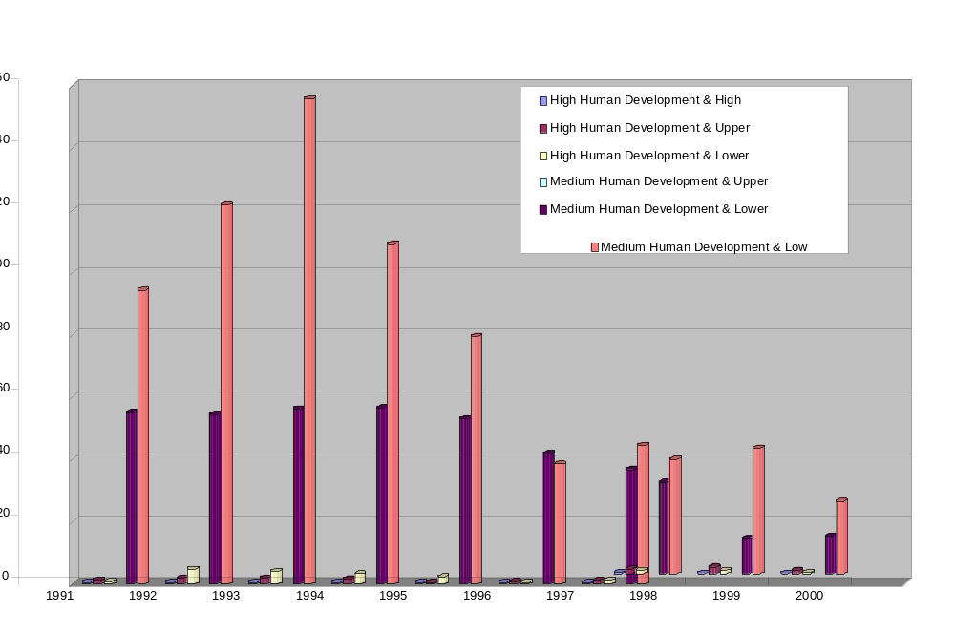

Source: WHO, 2002

A similar relationship between European countries with a medium HDI and a lower middle/low income was found with regard to incidences of viral hepatitis A per 100 000, figure 12.2, but with less improvement during the 1990s. Lower middle income was also a strong determinant of the incidence in countries with high HDI until 1998.

Figure 12.2 Viral Hepatitis A Incident per 100 000
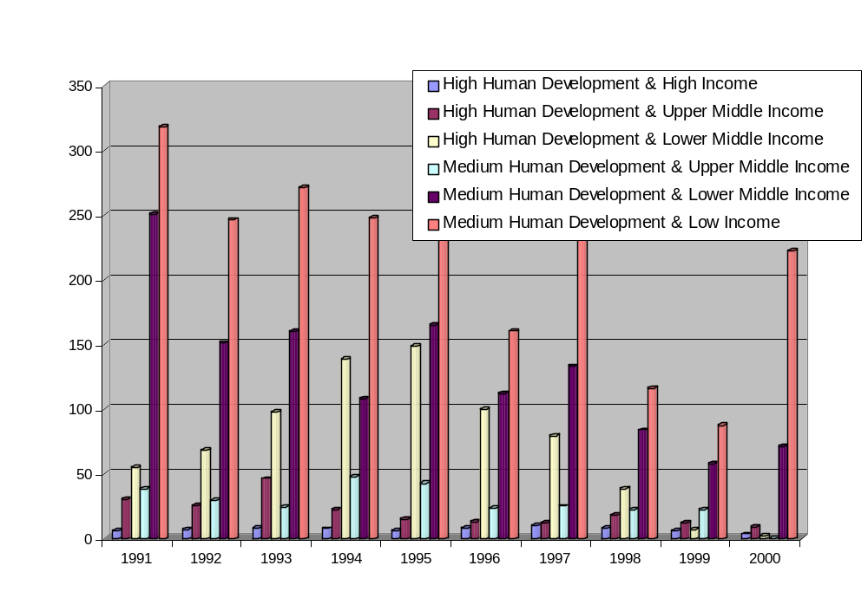

Source: WHO, 2002

12.2.2. Compliance with drinking-waterstandards
WHO guidelines for drinking-water quality recommend that indicators of faecal contamination (E coli or thermo-tolerant coliform bacteria) should not be detectable in any 100ml sample of water intended for drinking, water entering the distribution system, or water within the distribution system. An overview of results is given in figure 12.3.

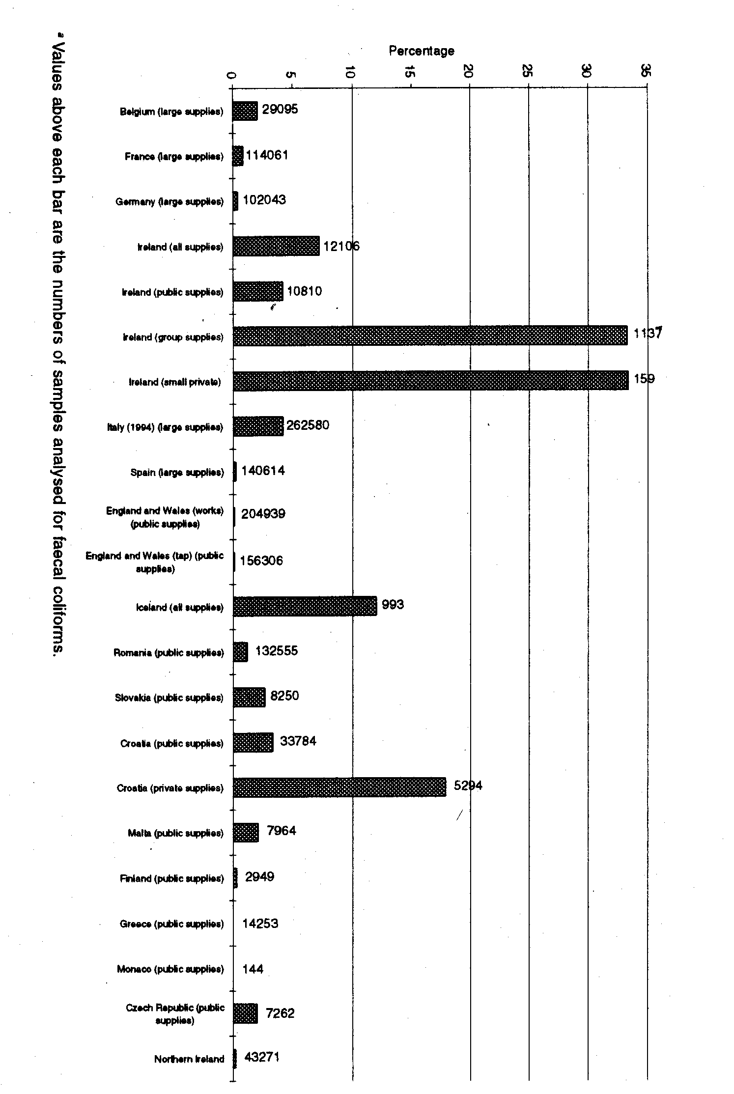
Fig. 12.3 Percentage of drinking-water samples exceeding national standards for faecal coliform bacteria in 1995

Source: WHO, 2002

It is not possible from the material available to establish a direct relation between exceedances of standards and occurrence of drinking-water related diseases, but, generally speaking, the higher the exceedance in each case and relatively (i.e. percentage of all samples exceeding standards), the higher the risk of drinking-water related diseases.

12.2.3. Chemicals and drinking-water quality
WHO has established guideline values for more than 100 chemicals in drinking water, all being of health concern. However, in European countries only a few are important for routine monitoring purposes: lead, arsenic, fluoride, nitrate/nitrite and pesticides. Only nitrate/nitrite and pesticides will be dealt with here since they are the ones that most frequently give rise to health concerns.

High concentrations of nitrate in drinking water are of concern because nitrate can be reduced to nitrite, which can cause methaemoglobinaemia, a disease especially dangerous in babies (blue baby syndrome). Progressive symptoms are stupor, coma and, in some cases, death. Occurrence of methaemoglobinaemia in selected European countries is illustrated in figure 12.4.

Fig. 12.4 Incidence of methaemoglobinaemia in selected European countries, 1996
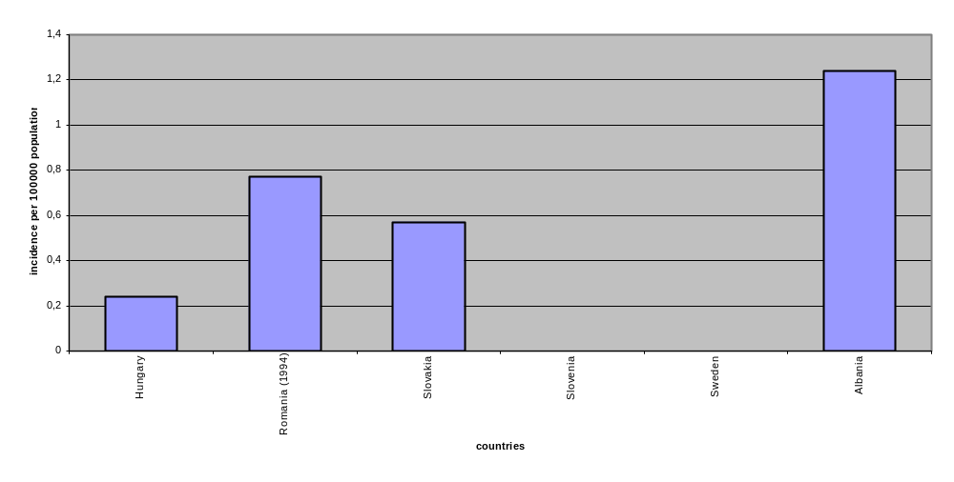
Note: Records for methaemoglobinaemia in Romania are for cases related to well water only.
Source: WHO, 2002

Analysis of methaemoglobinaemia-related data has been made in several countries. For instance, in Romania between 1985 and 1996, 2 913 cases were recorded of which 102 were fatal. The severest conditions prevail when drinking water is contaminated microbially and with high concentrations of nitrate (maybe up to 1 000 mg/l) at the same time.

Water resources located in intensively-farmed agricultural land are liable to be contaminated by nitrate. Consequently the rural population is at highest risk.

An overview of the percentage of drinking-water samples exceeding the national standard for nitrate in some European countries in 1995 is given in figure 12.5. The differences in concentrations related to different water sources experienced in Ireland and Croatia should be noted.
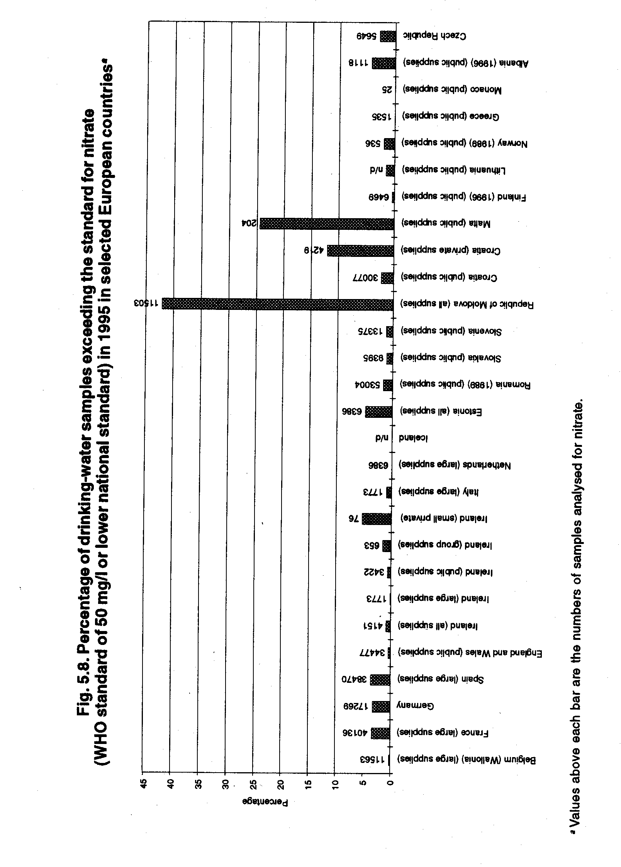
Fig. 12.5. Percentage of drinking-water samples exceeding the standard for nitrate in 1995 in selected European countries
Source: WHO, 2002

Some countries in Europe consider contamination by pesticides to be among their major problems in drinking-water quality. A number of reports on exceedances of standards (for EU countries) and/or WHO guidelines exist, some of the exceedances being quite severe and frequent. For example, 12.3 % of drinking-water samples tested in 1995 in England and Wales exceeded the national standard for isoproturon of 0.1 ug/l.

Nevertheless, the significance of concentrations exceeding EU standards or WHO guidelines to human health is unclear. No causality between exceedance of EU standards or WHO guidelines for pesticides and incidents of morbidity or mortality has been established, probably because the safety margin built into EU standards/WHO guidelines is considerable.

Table 12.2 Percentages of the population served by piped water supply in selected countries of the European Region, 1980s

Country | Total population served by piped public water supply | Urban population served by house connection | Rural population served by piped water supply at home
 | %
Albania | 92 | 100 | 88
Austria | 80 | 100 | 70
Belgium | 97 | 100 | 90
Bulgaria | 98 | 100 | 94
Denmark | 88 | 100 | 99.98
Finland | 88 | 96 | 85
France | 98 | 100 | 95
Federal Republic of Germany | 97.8 | 100 | 97
Greece | 86 | 91 | 73
Hungary | 84 | 91.5 | 74.3
Iceland | 100 | 100 | 100
Ireland | 90.6 | 98.7 | 80.5
Israel | 99.9 | 100 | 98
Italy | 98.8 | 100 | 96
Luxembourg | 99 | 100 | 97.6
Malta | 98 | 100 | 96
Monaco | 100 | 100 | -
Netherlands | 99.2 | 99.8 | 95
Norway | 87 | 100 | 34.7 (public)  65.3 (private)
Poland | 79.9 | 93.1 | 55.8
Portugal | 58 | 97 | 50
Romania | 52.3 | 91 | 17
Spain | 80 | 90 | 50
Sweden | 86 | 100 | 18
Switzerland | 99 | 100 | 99
Turkey | 69 | 72.8 | 66
USSR | - | 98 | 86
United Kingdom | 99 | 99.5 | 91.5
Source: WHO Regional Office for Europe, 1989

12.2.4. Water supply, coverage
The percentages of the total population served by piped water supply in Europe mostly varies between 50 and 100 %, with over or well over 90 % in many countries (table 12.2). The proportion of the population connected can vary significantly between different areas of the same country. For example, 78 % of the population in the north-eastern part of Italy is connected to a public supply, compared with only 27 % in the Italian Islands. The rural population, which in many countries account for around 50 % of the total population, is worst supplied. Only in a few countries (e.g. Iceland, Norway, Denmark) is all of the rural population connected to a home water supply, while in Turkmenistan and Ukraine only 5 % and 12 % respectively enjoy the same facility.

Some of the figures reported seem to be unlikely, e.g. that 94 %, 88 % and 86 % of the rural population in Bulgaria, Albania and the former USSR respectively are served by piped water supply at home. The 17 % reported for Romania seems more realistic. The situation in NIS countries has not improved over the last decade. On the contrary, many of the supply systems in the NIS, especially in rural areas, broke down during the first half of the 1990s due to lack of economic resources for repair and maintenance and are now beyond rehabilitation. In these areas people rely on local, often individual, water sources and latrines, a situation which frequently causes a health hazard because of the short distance between drinking-water intake and a possible source of faecal contamination.

12.2.5. Discontinuity

Discontinuity of supply, especially when combined with severe leaks in supply pipelines, also affects drinking-water quality and thereby health. Problems in providing the population with continuous supply vary from non-existent in some countries to being of major importance in some eastern European countries and NIS, mostly due to economic difficulties, lack of maintenance, or interruptions in power supplies. In many towns of these countries, the population only has water supply during a few hours per day and water pressure is often only sufficient to reach the lowest two to four floors of apartment buildings. People are often tempted to leave their taps open in order to collect a few buckets of water when it comes, which, although understandable from a human point of view, causes much water loss.

12.2.6. Leaks
Leaks are not only a question of waste of resources, they also affect health as they serve as entry points for contaminants. The more leaks, the more the health hazard, especially if leaks are associated with discontinuity of supply as vacuum will then easily occur. Losses vary from country to country and within the same country, table 12.3. Leaks cannot be totally avoided, and poor metering and monitoring in some countries make accurate estimates difficult. However, 10 % or less loss through leaks would be a good benchmark.

Table 12.3 Estimated loses from water networks in selected European countries, mid 1990s
Country: | Comments/observations:
Albania | Country Estimated losses from water networks Albania Up to 75%
Armenia | 50-55%
Bulgaria | Sofia 30-40%  Other than Sofia – more than 60%
Croatia | 30-60%
Czech Republic | 33%
France | 30% National average, 1990,  Paris 15%  Highly rural areas 32%
Germany  (western Germany) | 3700 litres per km of mains pipe per day 112 litres per property per day
Hungary | 30-40%
Italy | National average 15%  Rome 31%  Bari 30%
Kyrgyzstan | 20-35%
Republic of Moldova | 40-60%
Romania | 21-40%
Slovakia | 27%
Spain | Settlements> 20 000 population  20% Madrid  Bilbao 40%
Ukraine | About 50%
United Kingdom (England and Wales) | 8400 litres per km of mains pipe per day 243 litres per property per day
Sources: Mountain Unlimited 1995, 1997; Water Research Centre, 1997; Instituto di Ricerca, 1996 - Source: WHO, 2002

12.2.7. Consumption

The big differences in drinking-water consumption patterns between western and eastern Europe are probably the result of inappropriate consumption habits due to discontinuity of supply and leaks. Other reasons may be low water prices and lack of awareness-raising campaigns. While 150 – 300 l/person/day seems to be the norm in western Europe, 400 – 600 l/person/day occurs quite frequently in many towns of eastern Europe and the NIS. In addition to the waste of resources, this also adds to the economic difficulties of public utilities in these countries. Water abstraction, treatment and pumping are quite expensive. From a health point of view this money could be better used to repair leaks and ensure continuity of supply. This should be considered a priority area of effort for most east European countries and all the NIS.

12.2.8. Sanitation, coverage
The global coverage of sanitation by world region in 2000 has been estimated in WHO, 2001. The situation in European urban areas is comparable to those in North America and Oceania (nearly 100 % coverage), while the situation in European rural areas (about 70 % coverage) is worse than in North America and Oceania (80 % upwards). The percentage coverage is barely increasing over time. In this estimate ‘sanitation’ is understood as any kind of disposal facility, on- or off-site. It does not necessarily mean that a sewerage system is available.

The linkage between water supply, sanitation, hygiene and health is important. In a household without tap water it is difficult to make a flushing toilet work properly, if at all, and it is a demanding exercise and work to keep personal hygiene, the cleanliness of the dwelling and clothes at a satisfactory level. Hygiene, well-being, and consequently health, are at serious risk

No assessment of sanitation coverage in European sub-regions is available.

12.2.9. Recreational water
Recreational water environments have a diverse range of hazards to human health. These include factors associated with microbial pollution, accidents, exposure to toxic algae products, occasional exposure to chemical pollution and sunburns.

Clear evidence indicates that exposure to faecal pollution when bathing leads to health effects. Gastroenteritis is the most frequently reported adverse health outcome investigated, and evidence suggests a causal relationship between increasing recreational exposure to faecal contamination and frequency of gastroenteritis. There is also reason to believe that other severe infectious diseases such as typhoid fever and viral diseases such as hepatitis A and E may be transmitted to susceptible bathers who make recreational use of polluted water.

Monitoring for compliance with EU and national standards or WHO guidelines has been used for a number of decades as a tool to ensure bathing water quality that is not likely to cause harm to health. Compliance In EU countries is increasing slightly for seawater bathing points, while a considerable improvement has been noted for freshwater bathing points in the period 1993 (30 % of sites complying) to 1997 (80 % of sites) (WHO, 1999). Results in five non-EU countries are similar (WHO 2002), but data are too few and sporadic for a comprehensive assessment of the situation in non-EU countries.

Like any kind of compliance monitoring, bathing water quality monitoring always gives a retrospective picture of the situation. Efforts are therefore being made to develop another approach to classify beaches for health risk by combining a measure of faecal contamination with an inspection-based assessment of the susceptibility of an area to direct influence from human faecal contamination ( WHO, Regional Office for Europe, 2002).

An overview of mortality rates from accidental drowning and submersion per 10 000 population in 38 European countries in 1994 is given in WHO, 2002. Data suggest that males are more likely to drown (range: 0.08 per 10 000 population for UK to 3.77 for Latvia) than females (range: 0.02 for UK to 0.55 for Lithuania), but it is not clear whether this is because more males swim. Greater alcohol consumption by men is also a contributing factor, as are heart attacks, sea currents and surf.

In terms of all accidental deaths in the European Region, drowning accounts for less than 10 % of the 280 000 deaths due to accidents.

While discussions of the health hazards associated with recreational use of bathing water and beaches have concentrated on compliance with bathing water quality standards and the data on drowning/submersion), other health hazards like incidental cuts (sharp stones, metal and glass pieces, needles, urchins) and sunburns that can lead or contribute to development of skin cancer may be more important in terms of morbidity and mortality.

12.3 Ambient Air Quality
Two major groups of substances are of primary health importance in relation to air quality: particulate matter (PM) and heavy metals.

12.3.1. Particulate Matter
There have been several studies on exposure to PM leading to morbidity and mortality from respiratory or cardiovascular diseases.

PM covers a highly correlated mixture of primary pollutants such as black smoke (BS), SO₂, NO_{x} and CO. Association of health outcomes with concentration of suspended PM is best established for respirable or inhalable particles (PM₁₀ or PM_{2.5}). However, data from routine monitoring of PM₁₀ is available from a limited proportion of cities, and even fewer regularly collect data on PM_{2.5}. Therefore, data for total suspended matter (TSP) or BS were alternatively used for estimation of health impacts, using the risk coefficients obtained in studies based on the same exposure matrix to calculate an annual average PM₁₀. The resulting population exposure is presented in figure 12.6.

Figure 12.6. Population exposure to estimated PM₁₀ levels in124 cities included in WHO analysis
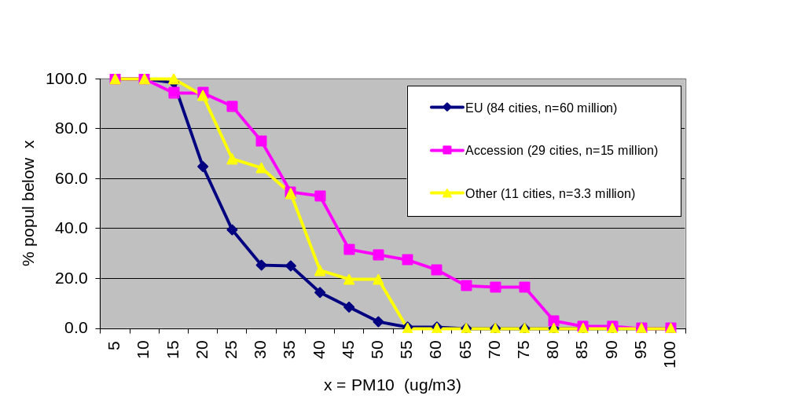
Source: WHO, 2001

The figure shows that more than half of the population of cities participating in the WHO project are exposed to PM levels higher than the target limit value of 40 ug/m³ in the accession countries, while the exceedance is estimated at only 14 % of the population in EU cities.

An estimate of mortality due to long-term exposure, assuming that the risk of mortality increases linearly with annual concentrations of PM, showed (WHO, 2001) that around 60 000 deaths per year may be associated with the long-term exposure to particulate air pollution exceeding the level equivalent to PM₁₀ = 5 ug/m³ in the 124 cities with PM data. If this number is extrapolated to the whole urban population of Europe, the number of deaths is four times greater (i.e. about 240 000), and life is shortened, on average, by at least a year in each of the cases, significantly contributing to the burden of disease in Europe.

The proportion of mortality associated with PM is greater in the accession countries than in the EU cities. Exceedances of the 2001 target limit value of 40 ug/ m³ account for about 1 % of mortality due to natural causes in EU cities, and 5 % in the accession countries.

Studies have also been performed on the relationship between exposure to PM and respiratory or cardiovascular diseases leading to admission to a hospital. In 91 cities with daily average PM₁₀ data included in the analysis, the daily variations in PM levels above 10 ug/ m³ were associated with nearly 6 700 admissions for respiratory diseases and 2 600 admissions for cardiovascular diseases per year. If the PM pollution is assumed to be similar in other cities of the region, then the number of hospitalisations associated with the daily increases of PM levels would amount to 47 000 per year, the incidence rate being markedly higher in the accession countries than in the EU.

Finally, a study in Austria, France and Switzerland (Federal Department of Environment, Transport, Energy and Communications, 1999) attributed about half of all mortality caused by air pollution to motorised traffic (see Transport chapter).

There are no air quality monitoring data from the NIS that allow reliable health impact assessment for these countries. However, the scarce and not very precise information available indicates that urban air pollution levels in large cities of the region are higher than in the western parts of Europe, so the health impacts may be expected to be significant. The situation highlights the need for improvement of assessment capacities, as a necessary part of air quality improvement programmes.

There is an uncertainty factor of at least two in these estimates and calculations, which also take no account of whether the sources are local or long-range. In many populated areas, particularly where there are no heavily-polluting local sources of particulate matter, as much as 40 – 60 % of PM₁₀ levels may be attributable to long-range transport, which is therefore a substantial contributor to the total exposure of the European population to airborne particulates.

The considerable contribution of PM to health problems in Europe makes a reduction in PM concentrations in cities, particularly from motorised transport, and from long-range transport a priority area for future air pollution abatement.

12.3.2. Heavy metals
Heavy metals such as cadmium, lead and mercury are common air pollutants and are emitted predominantly into air as result of various industrial activities. Their long-range transboundary effects have been assessed in a number of studies (WHO and UN-ECE, 2002). Lead appears to be the most important from the health point of view.

Lead and its compounds may enter the environment at any point during its mining, smelting, processing, use, recycling or disposal. Children constitute the critical population for environmental lead exposure which may influence cognitive functions as well as the central nervous system. The influence may occur when living in close proximity to point sources of emission, by exposure to lead paint flakes or lead-contaminated soil; long-range transport of lead is assumed to contribute about 0.03 % to the actual lead content in the topsoil layer and therefore does not influence the lead content of food to any significant degree. A persisting, local problem is exposure to lead from its continued use in transport fuels in several countries in the eastern part of the region, in spite of commitments made by ministers of transport and environment at the Vienna Regional Conference on Transport and Environment (Vienna, November 1997) to phase out leaded gasoline.

