Transfer from the airport to Ljubljana

By taxi

The taxi rank is right in front of the terminal. Taxis are available according to the actual arrivals of flights.
A fare from the Airport to Ljubljana costs approximately 7.000 SIT (30 EUR) (depending on the desired destination of the trip).
Telephone number: +386 4 20 61 678.

By bus

Airport bus timetable

Official bus service

From the airport to Ljubljana
From Monday to Friday
5.00 | 6.05 | 7.00 | 8.00 | 9.00 | 10.00 | 11.00 | 12.00
13.00 | 14.00 | 15.00 | 16.00 | 17.00 | 18.00 | 19.00 | 20.00
Saturdays, Sundays and Holidays
7.00 | 10.00 | 12.00 | 14.00 | 16.00 | 18.00 | 20.00
From Ljubljana to the airport
From Monday to Friday
5.20 | 6.10 | 7.10 | 8.10 | 9.10 | 10.10 | 11.10 | 12.10
13.10 | 14.10 | 15.10 | 16.10 | 17.10 | 18.10 | 19.10 | 20.10
Saturdays, Sundays and Holidays
6.10 | 9.10 | 11.10 | 13.10 | 15.10 | 17.10 | 19.10
One direction takes approximately 45 minutes. Tickets are purchased on the bus.
For information about ticket prices, please call: +386 90 4230
Private Bus
Ljubljana Airport- Ljubljana City- Ljubljana Airport: the journey time of the one-way trip is 30 minutes. Single fare costs 1.000 SIT (approximately 4 EUR).
Departures (including Sunday and Holidays)
Departures from Ljubljana
5.20 | 06.15 | 10.25 | 12.15 | 14.10 | 15.30 | 17.00 | 22.30
Departures from Ljubljana Airport
7.30 | 9.55 | 11.30 | 13.45 | 15.00 | 16.00 | 18.10 | 21.50 | 23.00 | 24.00

Source: Ljubljana Airport: http://www.lju-airport.si/eng/vsebina.asp?IDm=100

Ljubljana map

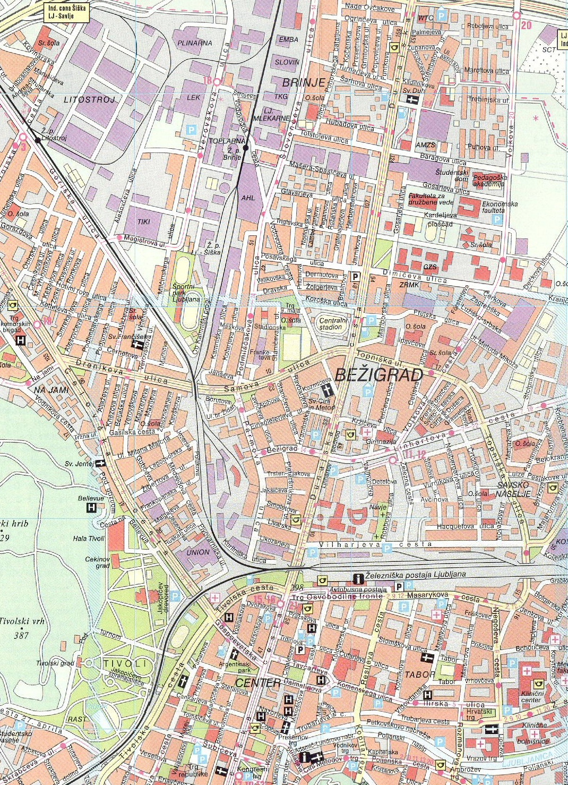
M Hotel
EARS
Hotel Lev
Hotel Slon
City Hotel
Grand Hotel Union, Garni
Hotel Emonec
Hostel CELICA
Grand Hotel Union, Business
Hotel Park
Grand Hotel Union, Executive
Domina Grand Media Hotel & Casino Ljubljana

Full city map of Ljubljana: http://www.euroave.com/maps/00mapx.php?xcity=ljubljana

Hotels in Ljubljana centre (20 minutes walking distance from the EARS):

Grand Hotel Union, Business (****)  Miklošičeva 3  SI-1000 Ljubljana  Tel: +386 (0)1 308 11 70  Fax: +386 (0)1 308 19 14  Internet: http://www.gh-union.si  E-mail: hotel.business@gh-union.si | 1 person 2 persons  Single 1/1 129 - 220 EUR 156 - 262 EUR  Double 1/2 140 - 234 EUR 164 - 283 EUR  Prices include overnight with self service breakfast and VAT.  Daily tax is 1 EUR per person.
Grand Hotel Union, Executive (****)  Miklošičeva 1  SI-1000 Ljubljana  Tel: +386 (0)1 308 12 70  Fax: +386 (0)1 308 10 15  Internet: http://www.gh-union.si  E-mail: hotel.union@gh-union.si | 1 person 2 persons  Single 1/1 136 - 220 EUR 163 - 262 EUR  Double 1/2 145 - 234 EUR 177 - 283 EUR  Prices include overnight with self service breakfast and VAT.  Daily tax is 1 EUR per person.
Hotel Lev (*****)  Vošnjakova ulica 1  SI-1000 Ljubljana  Tel.: +386 (0) 1 433 21 55  Fax: +386 (0) 1 433 20 03  Internet: http://www.hotel-lev.si/  E-mail: info@hotel-lev.si | Single standar1/1 120 - 200 EUR  Double 1/2-single use 130 - 220 EUR  Double 1/2 140 - 240 EUR  Business 160 - 250 EUR  Rates are inclusive of american buffet breakfast and VAT.  Daily tax is 1 EUR- per person.
Hotel Slon (****)  Slovenska cesta 34  SI-1000 Ljubljana  Tel.- central: +386 (0) 1 470 11 00  Tel.- reservations: +386 (0) 1 470 11 31  Fax: +386 (0)1 251 71 64  Internet: http://www.hotelslon.com/en/index.htm  E-mail - reservations: sales@hotelslon.com | 1 person 2 persons  Single 90 - 110 EUR 129 - 142 EUR  Single-Delux 123 EUR 172 EUR  2 persons 3 persons  Twin 161 EUR 189 EUR  Rates include accommodation, buffet breakfast, tourist tax and VAT.
Hotel Park (*/**)  Tabor 9  SI-1000 Ljubljana  Tel.: ++386 (0)1 300 25 00  Tel.: ++386 (0)1 232 13 98  Fax: ++386 (0)1 433 05 46  Internet: http://www.hotelpark.si/  E-mail: hotel.park@siol.net | Single 53 EUR  Double 70 EUR  Tourist tax is included.
City Hotel (***)  Dalmatinova 15  SI-1000 Ljubljana  Tel.: +386 (0)1 234 91 30  Fax: +386 (0)1 234 91 40  Internet: http://web.cityhotel.si/  E-pošta: info@hotelturist.si | Single 57 - 125 EUR  Double 109 - 139 EUR  Triple 127 - 150 EUR  Business 132 - 165 EUR  Prices include breakfast buffet, tourist tax and VAT.
Grand hotel Union – Garni  Miklošičeva 9  SI-1000 Ljubljana  Tel.: +386 1 308 43 00  Fax: +386 1 230 11 81  Internet: http://www.astralhotel.net/index.php  E-mail: hotel.garni@gh-union.si | Single 107 EUR  Double-single use 117 EUR  Double 140 EUR  Prices include buffet breakfast and VAT. Tourist tax is 0.66 EUR/person per day.
Hostel CELICA  Metelkova 8  SI - 1000 Ljubljana  Tel.: + 386 1 230 97 00  Fax: + 386 1 230 97 12  Internet: http://www.souhostel.com/en/index.html | Cell - 2 beds 5.250 SIT (22 EUR)  Cell - 3 beds 4.250 SIT (18 EUR)  Room - 3,4,5 beds 4.950 SIT (21 EUR)  Appartment - 4,5 beds 4.950 SIT (21 EUR)  Appartment - 6,7 beds 4.250 SIT (18 EUR)  All prices are per person per night and include: overnight stay, breakfast buffet, sheets, towels, VAT.

Hotels further than twenty-minute walk from the EARS

Hotel Emonec (**)  Wolfova 12  SI-1000 Ljubljana  Tel.: +386 1 200 15 20  Fax: +386 1 200 15 21  Internet: http://www.hotel-emonec.com/default.htm  E-mail: hotelemonec@siol.net | Single 49 EUR  Double 59 - 69 EUR  Three bedded 83 EUR  Four bedded 96 EUR  Prices include self-service breakfast, tourist tax and 8.5 % VAT.
M Hotel (***)  Derčeva 4  SI-1000 Ljubljana  + 386 (0)1 513 7000  Fax: + 386 (0)1 513 7090  Internet: http://www2.m-hotel.si/en/index.html  E-mail: info@m-hotel.si | Single 60 - 80 EUR  For two people 90 EUR  Double bedded 110 EUR  Double bedded-single use 88 EUR  Prices include breakfast and tourist tax.
Domina Grand Media Hotel And Casino Ljubljana (****)  Dunajska cesta 154  Ljubljana  Tel.: +386 (0)1 5882500  Fax: +386 (0)1 5882599  Internet: http://www.dominagmljubljana.com/hotels/gmljubljana/eng/home.aspx  E-mail: grandmedia.ljubljana@domina.it | From 60 EUR  Average price 137 EUR

Learn more about Ljubljana from this site: http://www.ljubljana-tourism.si/

